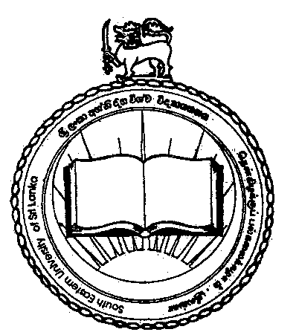44

11th GENERAL CONVOCATION - 2017
South Eastern University of Sri Lanka

The 11th General Convocation of the South Eastern University of Sri Lanka is scheduled to be held at the Bandaranaike International Conference Hall (BMICH), Colombo on 19th February 2017 (Sunday) in two sessions commencing at 8.00 am.

Session I - 8.00am to 10.30am
MBA [FMC], B.Sc (FAS), BA (FAC)

Session II - 11.00am to 1.00pm
BBA, B.Com, MIT (FMC, BA (FIA)

Issue of Cloaks & Garlands

Graduands of respective faculties are requested to collect the Cloak, Garland and Passes etc. on the following dates and places.

Date & Time | Graduands | Cloak Issuing Place
04.01.2017 from 9.30 am onwards | MBA (FMC) | Board Room, Admin Block, SEUSL, Oluvil
04.01.2017 from 9.30 am onwards | B.Sc (FAS)
04.01.2017 from 9.30 am onwards | BA (FAC) | Faculty of Arts and Culture, SEUSL, Oluvil
05.01.2017 from 9.30 am onwards | BBA, BCom, MIT (FMC) | Faculty of Management & Commerce, SEUSL, Oluvil
05.01.2017 from 9.30 am onwards | BA (FIA) | Faculty of Islamic studies and Arabic Language, SEUSL, Oluvil

In order to obtain the cloak and garlands, graduands should produce their Student Record Book or student Identity Card.

Return of Cloaks and Garlands

All Graduands of the Faculty of Management & Commerce are required to return their cloaks and garlands after the Convocation to the Academic and Student Affairs Division of the University on the following dates to collect their degree certificates. Student Record Book too should be surrendered on that day. If the cloak and garland are not returned on the date specified, a penalty of Rs. 500 / = per day will be levied. Please note that the Degree Certificate will not be issued if
the cloak and garland are not returned. Graduands should present themselves to collect their degree certificates. Degree certificate will not be issued to any other person on behalf of graduand.

Date & Time | Graduands | Cloak Returning Place
04.03.2017 from 9.30 am onwards | BA (FAC) | Academic and Student Affairs Division , Admin Block, SEUSL, Oluvil
05.03.2017 from 9.30 am onwards | MA, BBA, BCom, MIT (FMC)
06.03.2017 from 9.30 am onwards | B.Sc (FAS)
07.03.2017 from 9.30 am onwards | BA (FIA)

For further clarifications, please contact by Tel: 067 2255463 or Fax: 067 2255463.

MI. Nawfer
Acting Registrar

